Intelligent Diabetes Risk Predictor
Design Document

Version 1.0



Group Id: S26PROJECTA7FFD

Supervisor Name Komal Khawer

Revision History
Date (dd/mm/yyyy) | Version | Description | Author
07/06/2026 | 1.0 | The Intelligent Diabetes Risk Predictor is a machine learning-based decision-support system designed to assist patients and healthcare providers in predicting the likelihood of diabetes using clinical and lifestyle data. | Bc230206274

Table of Contents

1. Introduction to Design Document 5
2.1 Sequence Diagram 1: User Login and Health Data Submission 5
2.2. Sequence Diagram 2: Admin Model Training and Evaluation 6
3. Architecture Design Diagram 7
3.1 Layer Descriptions 8
4.Interface Design 8
5. Test Cases 8

1. Introduction to Design Document
A Design Document describes how a software system will be built. It translates requirements from the SRS into plans for developers. The SRS answers WHAT the system does. The Design Document answers HOW it will do it.

- Sequence Diagrams (To be developed using Rational Rose or any other drawing software of your choice)
A Sequence Diagram shows the order of interactions between parts of the system. It reads top to bottom like a timeline. Each vertical line is a participant (user, server, and database). Arrows between them show messages being sent. Solid arrows go forward (requests). Dashed arrows come back (responses).

Sequence Diagram 1: User Login and Health Data Submission
This diagram shows what happens when a patient opens the app, logs in, enters health data, and receives a diabetes risk result.
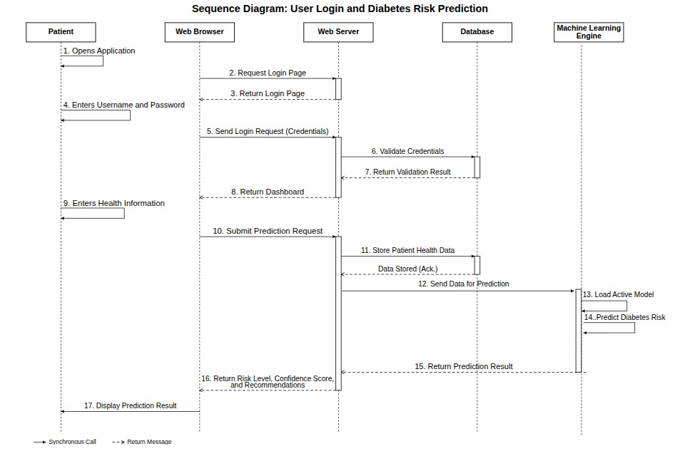

Step by step:
- Patient opens the app. Browser requests the login page from the web server.
- Patient enters username and password. Server checks the database.
- If credentials are valid, dashboard is shown. If not, an error appears.
- Patient fills in the health form and submits it. Server saves data to the database.
- Server runs the best ML model and sends the risk result back to the patient.

Sequence Diagram 2: Admin Model Training and Evaluation
This diagram shows what happens when an admin uploads a dataset, triggers training, and selects the best model.

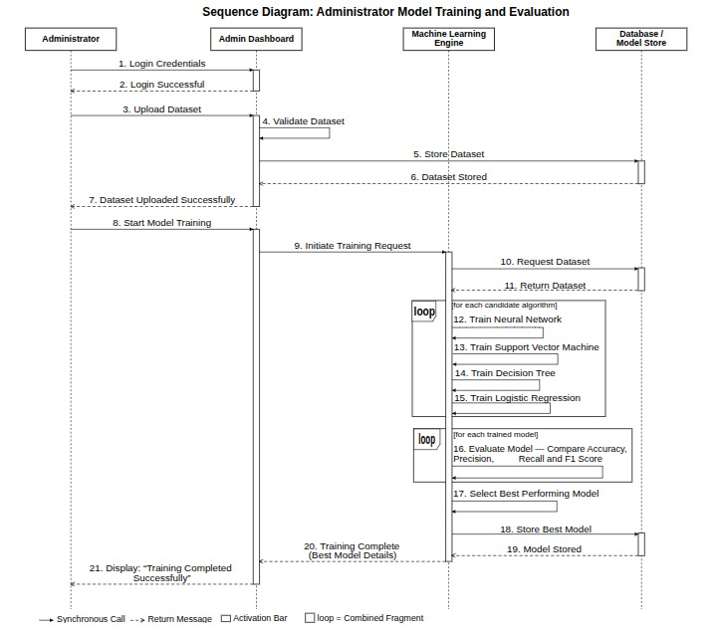
Step by step:
- Admin logs in and opens the admin dashboard.
- Admin uploads a dataset file. System validates and saves it.
- Admin triggers training. ML engine loads the dataset.
- Engine trains all four models and evaluates each one.
- Best model is saved to the model store and set as the active model.

3. Architecture Design Diagram
An Architecture Design Diagram shows the overall structure of the software system. It breaks the system into layers. Each layer has a specific job and only communicates with the layers above and below it. This makes the system easier to build, test, and maintain.

The Diabetes Risk Predictor uses four layers: Presentation, Application, ML Model, and Data.
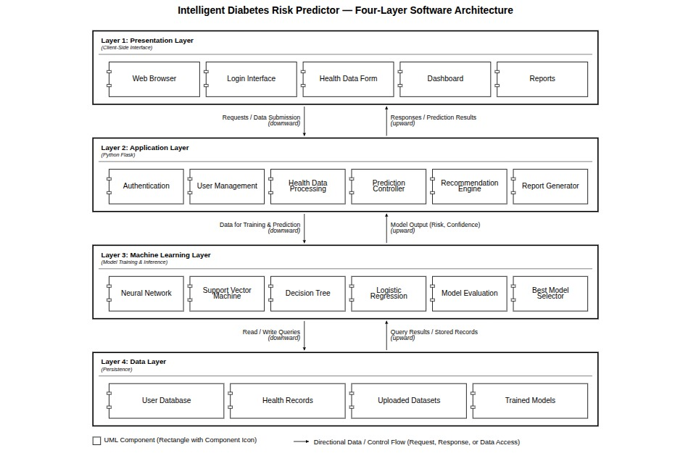

3.1 Layer Descriptions
Layer | Description and Technology
Presentation Layer | What users see and interact with. Includes the web browser interface, all screens (login, data input, dashboard, reports). Built using HTML, CSS, JavaScript, and Bootstrap.
Application Layer | Contains all business logic. Handles user authentication, data input processing, report generation, recommendations, and risk factor analysis. Built in Python using FastAPI.
ML Model Layer | The intelligence of the system. Contains the four trained models. The Model Evaluator compares them and selects the best one. Built using scikit-learn and TensorFlow/Keras.
Data Layer | Where all data is stored. Includes the user database, health records, trained model files, and uploaded datasets. Built using PostgreSQL

Interface Design
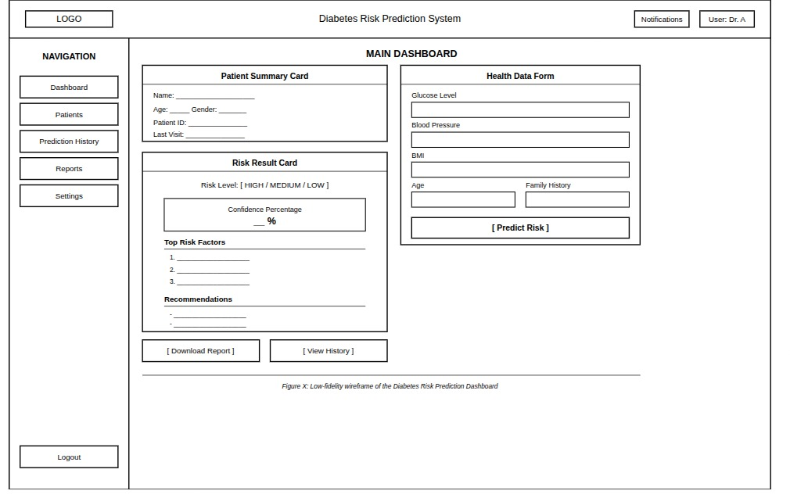

5. Test Cases
A Test Case is a set of conditions used to check whether a feature of the system works correctly. Each test case lists the input given to the system and what the correct output should be. If the system produces the expected output, the test passes.

These 20 test cases cover all 12 use cases from the SRS. Tests TC-19 and TC-20 cover the non-functional requirements for performance and security.
TC ID | Feature | Input | Expected Output | Pass/Fail
TC-01 | User Login | Valid username and password | User authenticated, redirected to dashboard
TC-02 | User Login | Wrong password | Error message shown, access denied
TC-03 | Health Data Input | All 8 fields filled correctly | Data saved, prediction triggered
TC-04 | Health Data Input | Missing glucose field | Field highlighted in red, form not submitted
TC-05 | Diabetes Prediction | Valid complete health data | Risk level High/Low shown with confidence %
TC-06 | Diabetes Prediction | Incomplete data submitted | Prompt to complete all required fields
TC-07 | Dataset Import | Valid CSV file uploaded by admin | Dataset stored, available for training
TC-08 | Dataset Import | Invalid file type (.txt) | File rejected, error message shown to admin
TC-09 | Model Training | Admin triggers training with valid data | All 4 models trained, metrics displayed
TC-10 | Model Evaluation | Training complete | Accuracy, Precision, Recall, F1, confusion matrix shown
TC-11 | Best Model Selection | Evaluation complete | Highest accuracy model selected as active
TC-12 | Report Generation | User requests report after prediction | PDF/CSV downloaded successfully
TC-13 | Risk Factor Analysis | Prediction result available | Top features shown in bar chart
TC-14 | Recommendations | High risk result | Diet, exercise, doctor visit suggestions shown
TC-15 | Health Tracking | Multiple past records exist | Trend graph of changes over time shown
TC-16 | Dashboard View | User logged in with predictions | Charts and risk summaries render correctly
TC-17 | Admin Model Mgmt | Admin opens model panel | All models, datasets, performance stats visible
TC-18 | Feedback Submission | User submits feedback | Feedback stored, visible to admin
TC-19 | Performance Test | 10 concurrent prediction requests | All complete within 3 seconds
TC-20 | Security Test | User accesses admin page without admin role | Access denied, redirected to login

